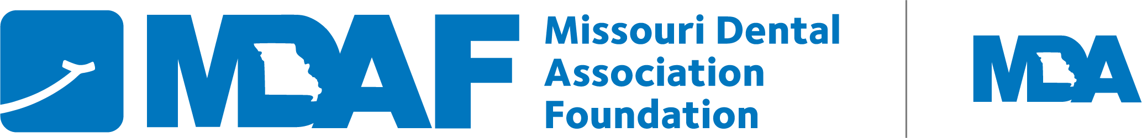

December 15, 2025
Dear Missouri Dental Students,
The MDA Foundation Dental Scholarship Program is now open to receive applications. The MDA is committed to supporting its future member dentists. We will award up to six $5,000 scholarships for the 2026-2027 academic year. They are competitive and will be based upon a matrix of leadership, future vision and scholarly achievement. The winners will be selected from all eligible applicants. The scholarship program is an initiative of the MDA Foundation in cooperation with the Missouri Dental Association. Applications must be postmarked (or received via email) by Friday, February 20, 2026.
Eligibility
- Students must be entering their 3rd or 4th year of dental school in fall 2026.
- Students must be graduates of a Missouri high school and must have been a resident of Missouri for a minimum of five years.
- Applicants should intend to practice in the state of Missouri after graduation.
- Previous recipients of MDA Foundation Scholarships are ineligible for a second MDAF Scholarship.
APPLICATIONS ARE DUE FEBRUARY 20, 2026.
APPLICANTS WILL BE NOTIFIED OF THEIR STATUS
NO LATER THAN MARCH 31, 2026.
Please carefully review the included application for specifics on:
- Application Requirements (including Missouri residency)
- Required Supportive Materials Checklist
- Essay Question
- Zoom Interview availability
- Check the correct box if you wish for your application materials to be reviewed by the Missouri Section of the American College of Dentists for separate consideration of its scholarship program.
We encourage you to be thoughtful in your essay question response, as it tells us the most about you and will account for 65% of the review process.
Send completed application and supporting documents to Margie Kunze by email at margie@modentalmail.org or mail to MDA Foundation, 3340 American Ave, Jefferson City MO 65109. If mailing, please submit your application singled sided with no staples. You may also contact Margie with any questions about the process. Thank you for your interest in our scholarships program and best wishes!
Sincerely,

Jeremy Bowen, DDS (UMKC 2007)
Chair, MDA Foundation

